WEBSITE SPECIFICATION DOCUMENT
WEBSITE INTRODUCTION
NeuroTech Robotics is a student-led club that brings together enthusiastic engineers to learn more about the diverse fields of robotics that is: of industrial and agricultural to medicinal, service, and educational robotics. The club provides a hands-on platform where students design prototypes, experiment with emerging technologies, and apply engineering principles to solve real-world challenges. By combining creativity, teamwork, and Scientific exactness, NeuroTech Robotics empowers its members to gain practical skills, contribute to community development, and prepare for global STEM opportunities.
The NeuroTech website is explicitly educational, designed to provide information and member engagement. The target audience for NeuroTech Robotics is students aged 16 and older (senior and tertiary learners) interested in information technology who are residents of Botswana with minimum Junior Certificate qualifications and should have done computer studies, 16- and 17-year-olds are registered for by a guardian.
The primary goal of NeuroTech Robotics is to empower students to explore, design and apply robotics across different categories. We aim to bridge the gap between Botswana and technology. While the gap is narrowing, its still evident hence why we as NeuroTech, will position student as active contributors to the country’s digital transformation.
Students gain practical skills in coding, electronics and robot design which will build workforce ready for industrial automation, healthcare robotics and agricultural innovation.

2. INFORMATION DESIGN & TAXONOMY
Information Architecture: The website uses a hierarchical taxonomy categorized by robotics fields: Industrial, Educational, Medicinal, Service and Agricultural
Navigation: The navigation includes Home, About Us, Projects, Events and Contact. This is to ensure faster information access rather than scrolling through to find the piece of information the user might be looking for.

SITE MAP

FUNCTIONAL REQUIREMENTS
- Content & Information
- About section- introducing NeuroTech Robotics and its categories.
- Goals- To empower students to explore, design and apply robotics to position them as active contributors to the country’s digital transformation.
  - Objectives-Skill mastery-provide hands-on training coding, electronics/circuitry and robot design.
  - Innovation: Solve real-world problems/challenges through scientific exactness And experimentation.
  - Market readiness: Prepare students for workplace opportunities in industrial automation and global STEAM platforms.
- Projects- solutions that are already attempted by students
- events and ongoing competitions- hackathons, make-a-thon, first global robotics competitions, first Lego league competitions
- Students’ achievements and innovations- students’ achievements in competitions they have partaken in, their benefits to the world

- Navigation & structure
- Clear Menu bar-Home, About, Projects, News/Events, Contact
- Easy navigation
- Must Support taxonomy and information design

- User interaction
- Users must be able to contact the club via email or form
- Must support functionality for quick access to content

- Technical Requirements
- Hosted on GitHub
- Must use CSS, HTML and styling

- Branding and identity
NeuroTech Robotics Logo:
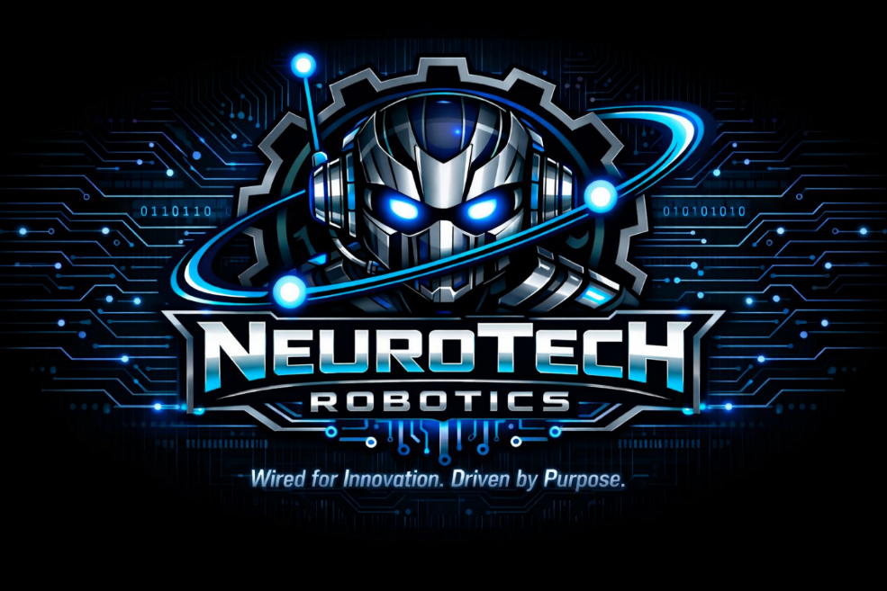
- Colours-black, neon blue, midnight blue
- Slogan: Wired by Innovation. Driven by purpose.

6.Accessibility
- Text must be readable and contrast should be clear
- Provide alt text for images
- Usable by diverse audiences even by ones with assistive technologies

INFORMATION DESIGN & TAXONOMY

Wireframe

LOGO AND SLOGAN

ABOUT US
PROJECTS
REGISTER NOW
EVENTS
CONTACT
HOME
WELCOME MESSAGE UPCOMING EVENT TEASER
TAGLINE FEATURED PROJECTS
BRIEF ROBOTICS CATEGORIES UPCOMING EVENT TEASER
CALL TO ACTON
FOOTER
COPY RIGHT
SOCIAL MEDIA LINKS
ABOUT US
CLUB INTRODUCTION, GOAL, OBJECTIVE
PROJECTS
INTERACTIVE GALLERY
PROTOTYPE IMAGES WITH ALT TEXT
EVENTS
EVENT TIME
WORKSHOPS & COMPETITIONS LISTED CHRONOLOGICALLY
CONTACT
EMAIL LINK
HOME

The layout includes a fixed navigation header, a hero section for the logo with slogan, active white spaces between content blocks to prevent clutter, register button, home section, about us section, projects section, event section, contact section, footer and a multi-column grade for robotics categories
Main Menu
- Home-Welcome message, tagline
- About Us- club introduction, goals, objectives and categories
- Projects-Gallery of prototypes
- Events-Timeline of workshops and competitions
- Contract-email link

Content Taxonomy
- Industrial Robotics-Automation, manufacturing prototypes
- Medicinal robotics- Assertiveness, healthcare innovations
- Service Robotics-Everyday support robots, usability projects.
- Agricultural Robotics-resource autonomy, precision yield
- Educational Robotics-knowledge transfer, STEAM scaffolding

TECHNICAL BRIEF
- Website specifications:
- Project Name: NeuroTech Robotics
- Platform: GitHub Pages
- Languages used: HTML5 for structure, CSS3 and Bootstrap framework for a responsive presentation layer and JAVASCRIPT for interactive gallery elements
- Purpose: to showcase club identity, project and robotics categories

Tools used
- Visual Studio Code: for coding
- Copilot: for logo design

